AIM OF THE POLICY

‘The specific aim of this policy is to outline the principles and procedure for both paid staff and volunteers in Lydney Hub to enable them to contribute to safeguarding the welfare of children and young people supported by Lydney Hub
It also seeks to protect the staff themselves especially detailing responsibilities and procedures pertinent to safeguarding

We recognise that:-
• The welfare of the child is paramount
• Everybody, regardless of age, disability, gender, racial heritage, religious belief, sexual orientation, identity or other characteristics have the right to equal protection from all types of harm or abuse
• All trustees, staff and volunteers of Lydney Hub must be aware of and fulfil their individual and organisational responsibilities in their role

POLICY PROCEDURES

Personnel/Recruitment
- See safer recruitment policy
- All applicants (paid or volunteer) to Youth Hub roles will complete an application form and be interviewed
- All applicants to roles are required to provide a reference which will be verifed
- All applicants are required to provide evidence of identity
- All Youth Hub staff who have contact with children and young people will have a disclosure and barring application check at an appropriate level to their role, They will be expected to sign up to the update service. They will not be permitted to attend sessions as a youth worker with young people before this is complete.
- All Youth hub staff who have contact with children and young people will receive Safeguarding training to Level 2 as part of their induction and throughout their employment

Responsibilities (organisation)
- Youth Hub will have 3 staff on site for every session as a minimum with a ratio of one adult to twelve children.
Lydney hub will have a minimum of one designated safeguarding lead with responsibility for safeguarding and child protection and the implementation of this policy
- The designated safeguarding lead will be required to have completed or be working towards a minimum requirement of level 3 safeguarding training
- All staff will be made aware of who the designated safeguarding lead is and how to contact them
- The designated safeguarding lead will ensure advice is sought from relevant child protection agencies when dealing with more complex issues

Responsibilities (designated safeguarding lead/s)
- The designated safeguarding leads are responsible for the implementation of this policy and to ensure they and others understand and follow the policy
- They have co-responsibility with Lydney Hub chair to ensure all disclosure and barring checks are up to date and safeguarding training for relevant staff is up to date
- They will undergo regular refresher training themselves relevant to their role to ensure they are as up to date as possible and in line with new guidance
- they will ensure that cases of suspected child protection or safeguarding concerns are actioned and referred to the appropriate agencies

Responsibilities (Youth Hub staff)
- All Youth Hub staff have a duty of care and responsibility for the welfare of the children and young people that they work with
- Youth Hub staff will wear an ID badge at each session
- Youth hub staff will understand and apply this policy in their role
- All staff have a duty to ensure that any suspected incident, allegation or other concern relating to child protection or safeguarding is reported using the reporting procedures detailed in this document
- If unsure or in doubt about what action to take, then staff must take advice from one of the safeguarding leads
- youth Hub staff will not be alone with young people, take young people to their homes or develop relationships with young people outside the youth Hub setting

Mobile Phones
- Staff are not permitted to use personal mobile phones at any time when working with children and young people
- Staff are not permitted to give exchange personal numbers with any children or young people in their care
- Staff should not use their own phones to take photographs

Social Media
- See social media policy

Photography
- See Social media policy
- Photographs are only allowed when explicit consent has been provided by the child, young person and their parent. These should only be taken by the Youth Hub phone, deleted after use stored for no more than 12 months and consent can be withdrawn at any time by the young person

Figure 1: What to do if you have concerns for the safety of a child, young person:

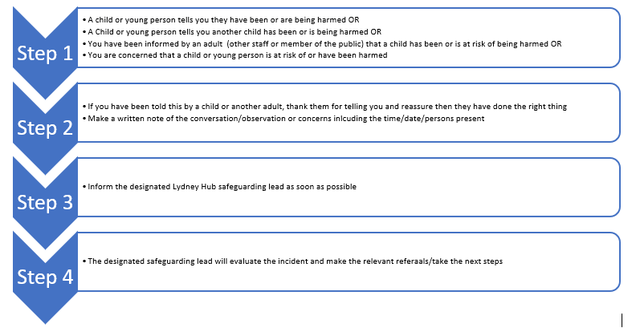

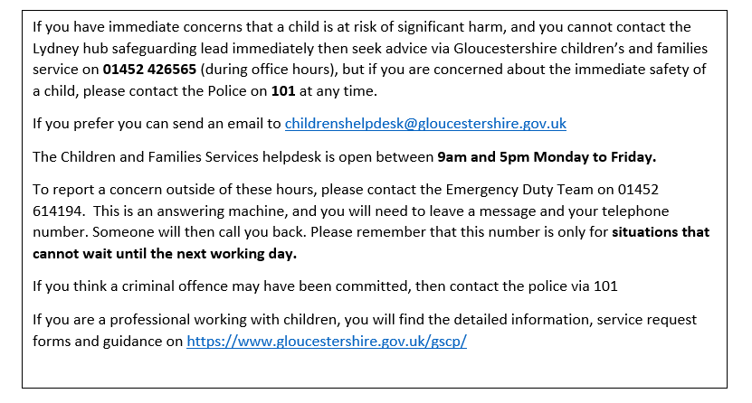

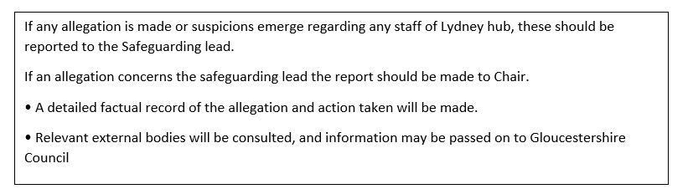

Signed by the board of trustees:

 | Name | Signature

Trustee 1

Trustee 2

Trustee 3

Trustee 4

Trustee 5

Trustee 6

Trustee 7

Trustee 8

Trustee 9

Trustee 10

Next Review date: October 2023

Document Version History |  | Author: Emily Timmins, Chair & Youth lead
Version | Date | Amendments | By Whom

